Lab 8 - Form Processing using Django – Part I

Q1 - Develop a web application using Django framework to demonstrate the transfer of
multiple parameters between web pages. User should be presented with a dropdown
list containing car manufacturers, a text box which takes model name of the
manufacturer and a submit button. On submitting the web page, the user is forwarded
to a new page. This new page should display the selected car manufacturer name and
the model name.

Code -

#urls.py
from django.contrib import admin
from django.urls import path
from car_app import views

urlpatterns = [
path('admin/', admin.site.urls),
path('', views.car_form, name='car_form'),
path('result/', views.result, name='result'),
]

#views.py
from django.shortcuts import render

def car_form(request):
manufacturers = ["Toyota", "Ford", "Honda", "BMW", "Tesla"]
return render(request, 'car_app/car_form.html', {'manufacturers': manufacturers})

def result(request):
if request.method == "GET":
manufacturer = request.GET.get('manufacturer', 'Unknown')
model = request.GET.get('model', 'Unknown')
return render(request, 'car_app/result.html', {'manufacturer': manufacturer, 'model': model})

#car_form.html
<!DOCTYPE html>
<html lang="en">
<head>
<meta charset="UTF-8">
<meta name="viewport" content="width=device-width, initial-scale=1">
<title>Select Car</title>
<link href="https://cdn.jsdelivr.net/npm/bootstrap@5.3.0/dist/css/bootstrap.min.css" rel="stylesheet">
</head>
<body class="bg-light">
<div class="container d-flex justify-content-center align-items-center vh-100">
<div class="card shadow-lg p-4" style="width: 30rem; border-radius: 15px;">
<h2 class="text-center mb-4">Choose Your Car</h2>
<form action="{% url 'result' %}" method="get">
<div class="mb-3">
<label for="manufacturer" class="form-label">Manufacturer:</label>
<select class="form-select" name="manufacturer" id="manufacturer">
{% for manufacturer in manufacturers %}
<option value="{{ manufacturer }}">{{ manufacturer }}</option>
{% endfor %}
</select>
</div>
<div class="mb-3">
<label for="model" class="form-label">Model Name:</label>
<input type="text" class="form-control" name="model" id="model" placeholder="Enter Model Name" required>
</div>
<button type="submit" class="btn btn-primary w-100">Submit</button>
</form>
</div>
</div>
</body>
</html>

#result.html
<!DOCTYPE html>
<html lang="en">
<head>
<meta charset="UTF-8">
<meta name="viewport" content="width=device-width, initial-scale=1">
<title>Car Selection Result</title>
<link href="https://cdn.jsdelivr.net/npm/bootstrap@5.3.0/dist/css/bootstrap.min.css" rel="stylesheet">
</head>
<body class="bg-light">
<div class="container d-flex justify-content-center align-items-center vh-100">
<div class="card shadow-lg p-4 text-center" style="width: 30rem; border-radius: 15px;">
<h2 class="mb-3">Car Selection</h2>
<p class="fs-4"><strong>Manufacturer:</strong> {{ manufacturer }}</p>
<p class="fs-4"><strong>Model Name:</strong> {{ model }}</p>
<a href="{% url 'car_form' %}" class="btn btn-secondary mt-3 w-100">Go Back</a>
</div>
</div>
</body>
</html>

Output -

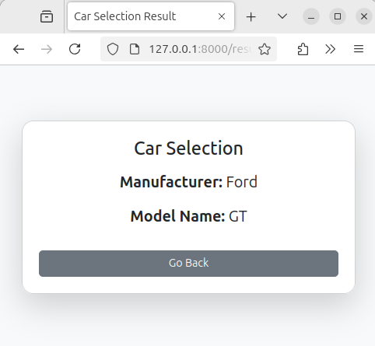

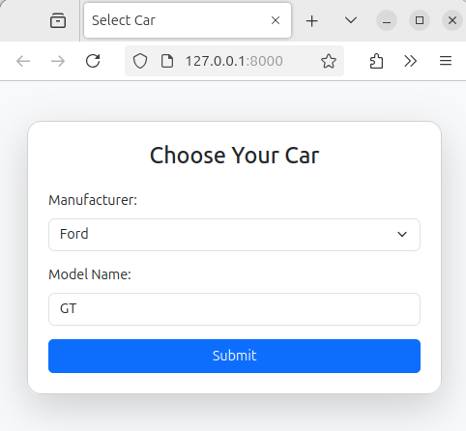

Q2 - Create a page firstPage.html with two TextBoxes [Name, Roll], DropDownList
[Subjects], and a button. Create another page secondPage.html with a label and a
button. When the user clicks the button in first Page, he should be sent to the second
page and display the contents passed from first page in the label. The button in second
page should navigate the user back to firstPage. Use Django sessions to transfer
information.

Code -

#urls.py
from django.contrib import admin
from django.urls import path
from myapp import views

urlpatterns = [
path('admin/', admin.site.urls),
path('', views.first_page, name='first_page'),
path('second/', views.second_page, name='second_page'),
]

#views.py
from django.shortcuts import render, redirect

def first_page(request):
subjects = ["Math", "Science", "History", "English", "Computer Science"]

if request.method == "POST":
name = request.POST.get("name")
roll = request.POST.get("roll")
subject = request.POST.get("subject")

request.session["name"] = name
request.session["roll"] = roll
request.session["subject"] = subject

return redirect("second_page")

return render(request, "firstPage.html", {"subjects": subjects})

def second_page(request):
name = request.session.get("name", "Unknown")
roll = request.session.get("roll", "Unknown")
subject = request.session.get("subject", "Unknown")

return render(request, "secondPage.html", {"name": name, "roll": roll, "subject": subject})
#firstPage.html
<!DOCTYPE html>
<html lang="en">
<head>
<meta charset="UTF-8">
<meta name="viewport" content="width=device-width, initial-scale=1">
<title>First Page</title>
<link href="https://cdn.jsdelivr.net/npm/bootstrap@5.3.0/dist/css/bootstrap.min.css" rel="stylesheet">
<style>
body {
background-color: #f8f9fa; /* Clean white background */
display: flex;
justify-content: center;
align-items: center;
height: 100vh;
}
.card {
width: 400px;
padding: 30px;
border-radius: 12px;
box-shadow: 0px 4px 10px rgba(0, 0, 0, 0.1);
background: #ffffff;
}
.form-control, .form-select {
border-radius: 8px;
padding: 12px;
}
.btn {
border-radius: 8px;
padding: 12px;
font-weight: bold;
transition: 0.3s ease;
}
.btn:hover {
background-color: #007bff;
color: white;
}
</style>
</head>
<body>
<div class="card">
<h2 class="text-center mb-3">Enter Details</h2>
<form method="POST">
{% csrf_token %}
<div class="mb-3">
<label for="name" class="form-label">Name:</label>
<input type="text" class="form-control" id="name" name="name" required>
</div>
<div class="mb-3">
<label for="roll" class="form-label">Roll Number:</label>
<input type="text" class="form-control" id="roll" name="roll" required>
</div>
<div class="mb-3">
<label for="subject" class="form-label">Subject:</label>
<select class="form-select" id="subject" name="subject">
{% for subject in subjects %}
<option value="{{ subject }}">{{ subject }}</option>
{% endfor %}
</select>
</div>
<button type="submit" class="btn btn-primary w-100">Go to Second Page</button>
</form>
</div>
</body>
</html>

#secondPage.html
<!DOCTYPE html>
<html lang="en">
<head>
<meta charset="UTF-8">
<meta name="viewport" content="width=device-width, initial-scale=1">
<title>Second Page</title>
<link href="https://cdn.jsdelivr.net/npm/bootstrap@5.3.0/dist/css/bootstrap.min.css" rel="stylesheet">
<style>
body {
background-color: #f8f9fa;
display: flex;
justify-content: center;
align-items: center;
height: 100vh;
}
.card {
width: 400px;
padding: 30px;
border-radius: 12px;
box-shadow: 0px 4px 10px rgba(0, 0, 0, 0.1);
background: #ffffff;
text-align: center;
}
.btn {
border-radius: 8px;
padding: 12px;
font-weight: bold;
transition: 0.3s ease;
}
.btn:hover {
background-color: #28a745;
color: white;
}
</style>
</head>
<body>
<div class="card">
<h2 class="mb-3">User Details</h2>
<p class="fs-5"><strong>Name:</strong> {{ name }}</p>
<p class="fs-5"><strong>Roll Number:</strong> {{ roll }}</p>
<p class="fs-5"><strong>Selected Subject:</strong> {{ subject }}</p>
<a href="{% url 'first_page' %}" class="btn btn-success w-100 mt-3">Back to First Page</a>
</div>
</body>
</html>

Output -

